Insulin Therapy of Diabetes:

Pathophysiology:

Patients With Diabetes Are Not Reaching Treatment Goals
We have a fairly generous toolbox of therapies for the treatment of patients with diabetes, and I will discuss the ways we can apply these therapeutic tools.
We have all heard about the explosion in the prevalence of diabetes; and frequently the term "epidemic" is used in this context. Currently, about 10% of adults in the United States have diabetes; that is, about 20 million people. Nearly a third do not know they have diabetes; that is a lot of people, but it is better than it was about 10 years ago when it was 50%.
In addition, and perhaps a little bit more alarmingly, is the fact that there are 2 to 3 times that number of people who have what is now called prediabetes; they either have impaired fasting glucose or impaired glucose tolerance. This category is very important because these individuals have a 40-fold likelihood of making the transition from prediabetes to actual type 2 diabetes. Although their vascular risk is not quite as high as in DM2, the increase in macrovascular disease in these individuals is substantial.
In addition, not all of those with prediabetes actually make the move to DM2, so attention is being drawn to this category as a legitimate treatment target. Consequently, about 1 out of every 3 adults in the US has either diabetes or prediabetes, which is a substantial number of people--70 or 80 million.
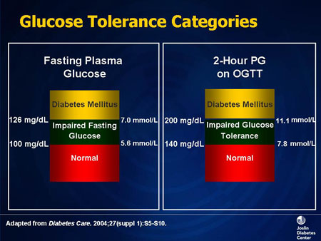
Slide 1. Glucose Tolerance Categories
When talking about the prediabetic state, make sure you are familiar with these glucose criteria: Normal (normoglycemia) is fasting blood glucose of less than 100 mg/dL, and diabetes is diagnosed at levels of 126 mg/dL or above. Two-hour postprandial glucose of 140 mg/dL or less is normal and a postprandial glucose of 200 mg/dL or over constitutes diabetes. Between these parameters are the categories of either impaired fasting glucose or impaired glucose tolerance. Prediabetes is no longer a descriptive term; it actually applies to a category of individuals who have blood glucose levels that fall within certain clearly defined parameters.
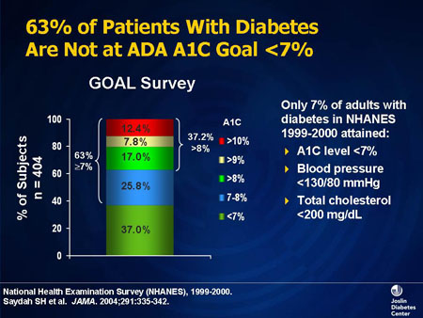
Slide 2. 63% of Patients With Diabetes Are Not at ADA A1C Goal <7%
Given the fact that we know all of this, it is surprising that we have not been able to make better penetration in terms of control of diabetes. This is information from the National Health and Nutrition Examination Survey (NHANES), which is a large, government-sponsored, population-based epidemiologic study that examined many conditions, including diabetes. This study tells us that only 37% of individuals with diabetes in the study population had hemoglobin A1C levels of less than 7%, which means that the other two thirds are above that fairly conservative American Diabetes Association (ADA) goal.
If you include other macrovascular risk factors that we are supposed to be controlling, only about 7% of adults with diabetes have an A1C less than 7%, blood pressure less than 130/80 mm Hg, and total cholesterol less than 5 mmol/L (200 mg/dL). This represents a substantial opportunity for improvement.

Pathogenesis and Etiology of Type 1 and 2 Diabetes
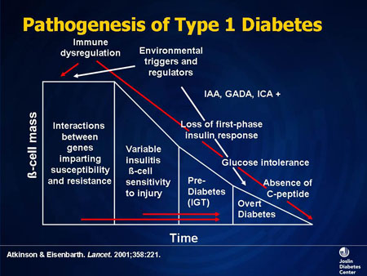
Slide 3. Pathogenesis of Type 1 Diabetes
The vast majority of diabetes is type 2 diabetes, but about 5% to 10% of individuals have type 1 diabetes. This is a complex condition of absolute insulin deficiency focused around immune dysregulation, immune disorders, in which autoantibodies are directed at various surface components of the beta cell, leading to diabetes. We used to think of it as childhood diabetes and as an explosive condition. But we know now, based on our ability to track autoantibodies and various circulating chemical markers, that there is a preamble to type 1 diabetes. Perhaps in the future we will be able to intervene before the beta-cell mass is decreased to the point where there is no insulin being produced.
The hallmark of type 1 diabetes from a clinical point of view is that these individuals cannot make any insulin, and therefore are dependent on external insulin for survival.
Of the 95% of people with type 2 diabetes, a substantial number will eventually need insulin therapy to control their blood glucose. However, they are not absolutely insulin-deficient, meaning they do make insulin, in some cases a substantial amount. But it is not enough to overcome their insulin resistance. Although they may require insulin, they are not dependent on insulin for survival; that is a critical differential between the pathogenesis of those two conditions.
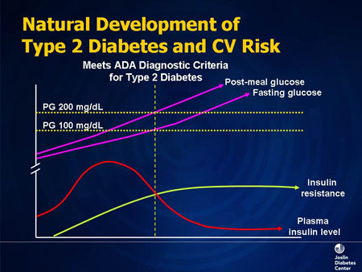
Slide 4. Natural Development of Type 2 Diabetes and CV Risk
In type 2 diabetes, the underpinning of its pathophysiology, insulin resistance, present in almost every individual with type 2 diabetes, starts early. By the time we diagnose diabetes, insulin resistance is essentially at or almost at a peak, and stays at that level for the rest of that patient's life unless we include a strategy in our therapy to reduce insulin resistance.
If you are a person with insulin resistance, meaning you are one of 70 to 80 million people, your response should be to make more insulin, to mount a compensatory hyperinsulinemia. And if you are an individual who has insulin resistance and you can make unlimited amounts of insulin, your blood glucose will remain normal. But if you are in that approximately 25% of insulin-resistant individuals who cannot continue to make insulin in unlimited amounts, your beta cells die, and as they fail, insulin levels will go down, followed by rises in postprandial and then fasting blood glucose. At that point, we will diagnose prediabetes or type 2 diabetes.
You can extract a number of things from diagrams such as this. One is that if you were able to raise the insulin level -- for example, you gave an insulin secretagogue, (e.g., a sulfonylurea) or insulin itself -- you might be able to lower or even normalize the blood glucose, but you still would not have done very much to reduce the insulin resistance. That is important, because the general feeling is that most of the macrovascular risk factors that we see clustered in these individuals are related to the insulin resistance and not necessarily to the hyperglycemia, per se.
Secondly, there is a lot going on before the diagnosis of DM2 is made. Insulin resistance has increased, and parallel to this increase is the development of macrovascular disease, which may start well before a patient is diagnosed with type 2 diabetes. The goal, then, is to intervene in the natural history of these patients much earlier, when their beta-cell mass is more substantial, because it is always easier to prevent things from happening than it is to try to reverse them after they have happened.
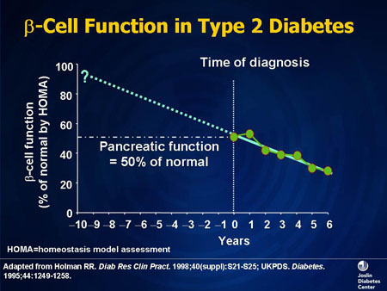
Slide 5. Beta-Cell Function in Type 2 Diabetes
Beta-cell function is the discriminating feature of people with diabetes; it is what determines blood glucose levels, because insulin resistance is at or near maximal by the time we diagnose diabetes. Consequently, the degree of dysglycemia is predominantly related to beta-cell function, and this starts to decline well before we diagnosis type 2 diabetes, possibly as long as 10 years prior to diagnosis. This is another good argument for getting involved earlier in the natural history of this condition.
The beta cell, the insulin producer, is subject to a number of factors that can lead to progressive malfunction. Hyperglycemia itself creates glucose toxicity: If blood glucose is high, this elevation in and of itself will impair insulin production and secretion, and also will increase insulin resistance. Conversely, when you lower blood glucose by any means, you may overcome some of the associated glucose toxicity and improve beta-cell function.
There also is a lipotoxicity. Insulin is an antilipolytic hormone; it keeps fatty acids in fat cells. But when you do not produce enough insulin or when there is insulin resistance, there is less insulin action. Free fatty acids, as well as other chemical products, flow from adipose tissue, accumulating in and affecting the function of the beta cell. We are even beginning to think of the beta cell as possibly being an insulin-sensitive tissue; at the very least, it seems to be a victim of the systemic chemical environment that accompanies insulin resistance. Therefore, strategies that lower insulin resistance may also improve beta-cell function. This is a very complex set of events, but it also presents multiple treatment targets as well.
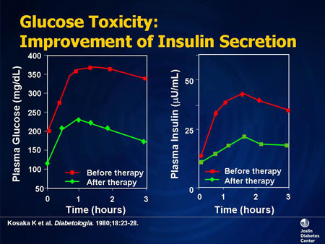
Slide 6. Glucose Toxicity: Improvement of Insulin Secretion
These data demonstrate glucose toxicity. If one tracks plasma glucose and plasma insulin, if you lower blood glucose (for example by giving insulin), you can improve insulin release. For example, if you have a patient who presents with a blood glucose level of 20-30 mmol/L (400 or 500 mg/dL), and you give that patient insulin at the beginning of their therapy and lower his or her blood glucose to normal, you may actually improve insulin production. Therefore, in some patients, the early administration of insulin may prevent the use of more complex regimens, or insulin altogether, at a later time.
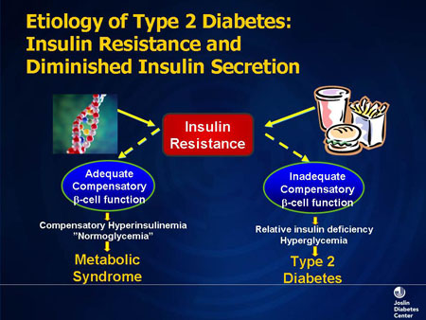
Slide 7. Etiology of Type 2 Diabetes: Insulin Resistance and Diminished Insulin Secretion
Insulin resistance occurs partially because of genetic predisposition (represented by double helix icon). Additionally, there are lifestyle issues -- eating too much, weighing too much, and not getting enough exercise -- represented by the fast food burger and fries. In that situation, if you can produce unlimited amounts of insulin, blood glucose will remain normal, but you may still have the metabolic syndrome, a cluster of risk factors related to insulin resistance. If you are in the 25% of people who cannot make enough insulin, your blood glucose will go up and you will be somebody with type 2 diabetes as part of your metabolic syndrome.
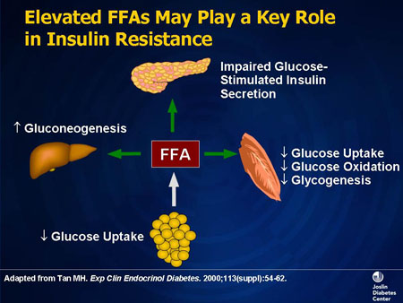
Slide 8. Elevated FFAs May Play a Key Role in Insulin Resistance
I would like to underscore the importance of free fatty acids. When released from adipose tissue, they end up in a number of tissues critical to the insulin resistant and dysglycemic state. In the liver, the net effect is to antagonize insulin action. We see less glucose staying in the liver and more gluconeogenesis and glycogenolysis, contributing to both fasting and postprandial hyperglycemia. But a large contribution to hyperglycemia comes from free fatty acids being deposited in muscle, since over 80% of glucose is taken up in muscle tissue. Free fatty acids can end up in the beta cell as well, where again there are structural and functional impairments of insulin synthesis and insulin release due to the lipotoxic part of beta-cell dysfunction.

Insulin Physiology: Normal and Diabetic States
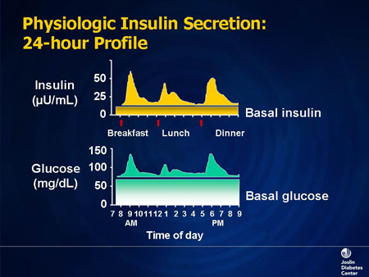
Slide 9. Physiologic Insulin Secretion: 24-hour Profile
The objective of insulin therapy is to recreate normal physiology. In the basal fasting state, blood glucose stays fairly constant. The level of insulin is low, but a basal amount is always present. Superimposed on the basal level will be bursts or spikes (sometimes referred to as a bolus) of insulin being released periodically into the circulatory system, to assimilate the carbohydrates that we have ingested. This concept of basal and bolus insulin as found in normal physiology is the platform upon which our insulin strategies are based.
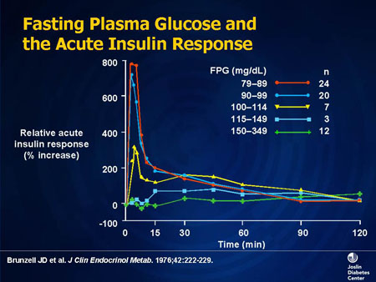
Slide 10. Fasting Plasma Glucose and the Acute Insulin Response
When people develop diabetes, they always produce insufficient amounts of insulin relative to the level of blood glucose and insulin resistance that exists. Type 1 diabetes patients have no insulin at all and type 2 diabetes patients have some insulin, but less than they need to keep their blood glucose levels normal. Shown here on the y-axis is insulin response as a percentage increase from baseline for groups of patients who have varying degrees of impaired glucose tolerance and a varying severity of diabetes.
What you see is more than an overall decrease in insulin production. The first thing to disappear is the "first-phase" or acute insulin response, during which nondiabetic individuals may have as much as an 8-fold increase in insulin production over the basal level. By the time you reach a fasting blood glucose in the highest range, there is practically no acute insulin response. When we construct insulin therapies, short-acting insulins best mimic this phase of insulin release.

Understanding A1C
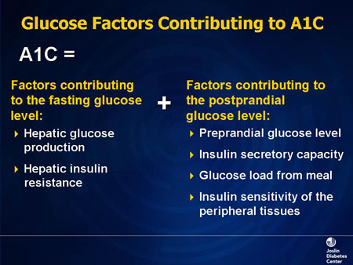
Slide 11. Glucose Factors Contributing to A1C
Hemoglobin A1C, which is the surrogate for mean integrated average blood glucose over a period of roughly 8 to 12 weeks, may represent many factors. Glucose is released by the liver to prevent hypoglycemia when not eating overnight. When there is decreased insulin activity, this process is dysregulated and you release too much blood glucose.
We also have a number of factors that not only contribute to fasting glucose, but also contribute to postprandial glucose, including insulin secretory capacity, how much glucose is ingested, and the sensitivity of the tissues to insulin. It is, then, a complex set of factors and regulators that contribute to the overall glycemic burden.
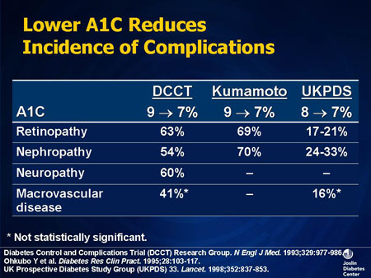
Slide 12. Lower A1C Reduces Incidence of Complications
We know that lowering A1C reduces complications. This is particularly true for microvascular complications, such as retinopathy or nephropathy, but also true, to perhaps a less robust degree, for macrovascular disease.
A number of studies have demonstrated this protection. The sentinel study for type 1 diabetes is the Diabetes Control and Complications Trial (DCCT), which included type 1 patients who were getting either conventional insulin therapy or an intensified insulin regimen of multiple doses per day, with A1C targets that were more aggressive.
In that study there were substantial reductions in all of the vascular parameters that were followed.
This same intensive insulin strategy was applied to type 2 patients in the Kumamoto study, and similar results were seen.
In another study of type 2 patients receiving not only insulin but also metformin (the United Kingdom Prospective Diabetes Study or UKPDS), diet and exercise, or a sulfonylurea, the same principle was reinforced; lowering A1C reduces the incidence of complications. To whatever degree that you can reduce A1C, whether it is 1% or 2%, or taking a patient from 10% to 9%, or 9% to 8%, you will convey a protective effect to their tissues.
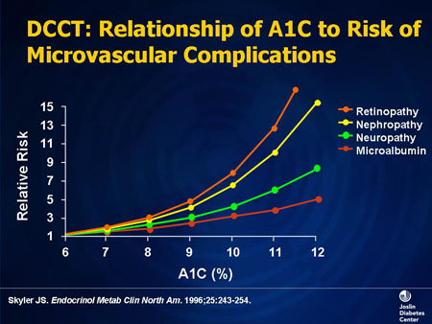
Slide 13. DCCT: Relationship of A1C to Risk of Microvascular Complications
This is another analysis of data from the DCCT, which examines individual complications: retinopathy, nephropathy, neuropathy, and microalbuminuria. All of these would be considered microvascular complications, which are very tightly linked to blood glucose. Macrovascular disease is more complex because we have many other risk factors such as lipids and hypertension that are contributing to the macrovascular disease.
As shown, no matter what the complication, there is a significant relationship between A1C and the relative risk of developing that complication. The higher the A1C, the more the complications or, conversely, the lower the A1C, the less the complications.
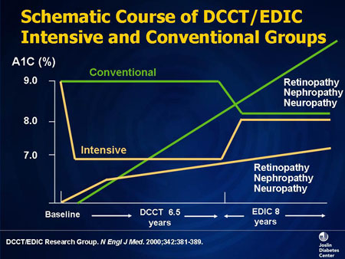
Slide 14. Schematic Course of DCCT/EDIC: Intensive and Conventional Groups
The DCCT investigators did something that was interesting. The original trial duration was 7 years. Patients were either given a conventional type of insulin regimen, perhaps 2 shots per day, or an intensive regimen where patients might get multiple subcutaneous injections and received very intensive management with a high ratio of healthcare personnel to patients. This intensive group had lower A1Cs during the study period.
After these DCCT results were published, the investigators followed patients for another several years. Not surprisingly, when the intensity of management was relaxed, A1Cs rose. In addition, during this period of time, the notion of being more aggressive about insulin therapy took hold in the medical community, and those patients who had initially received "conventional" therapy were actually getting a little bit better therapy than previously, and the two groups met in the middle in terms of A1Cs.
The investigators also tracked complications during this extended observation period. Patients who received conventional therapy at the beginning had a progressive increase in microvascular complications, whereas patients who had the initial intensive care were able to maintain their advantage in terms of reduced rates of retinopathy, nephropathy, and neuropathy. Note that the rate of complications between groups is not parallel; complications increased as A1C went up, but not as much in the intensive therapy group during this extended period of time, as in the conventional therapy group. So it appeared that there was some memory from the period of intensive control. These same trends were also shown for macrovascular disease.
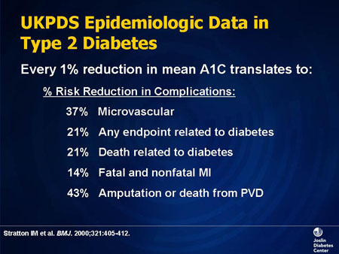
Slide 15. UKPDS Epidemiologic Data in Type 2 Diabetes
Data from the UKPDS for type 2 diabetes showed that a 1% reduction in mean A1C could result in the substantial percentage reduction shown for all of these various complication endpoints.
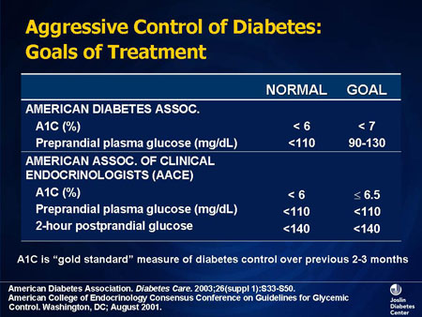
Slide 16. Aggressive Control of Diabetes: Goals of Treatment
There is no single agreed-upon A1C target, but most people would agree that the goal is to get A1C to normal without exposing the patient to undue risks of hypoglycemia. Organizational goals are always consensus statements; for the ADA, the A1C goal is less than 7% and for the American College of Endocrinology, it is less than/equal to 6.5%. But both groups acknowledge the fact that if you can get patients to normal, you should do so.

Patient Education and Monitoring
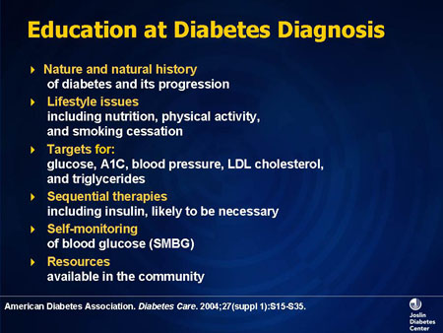
Slide 17. Education at Diabetes Diagnosis
We have a lot of therapeutic tools to offer patients. We have education. The role of Certified Diabetes Educators is inestimably important in terms of the breadth and depth of education they give in a number of areas, not only in disease education but education regarding various therapeutic modalities, explaining the nature of these therapies and getting patients involved in self-monitoring. Educators are able to devote the time and the skills necessary in terms of teaching patients about their diabetes
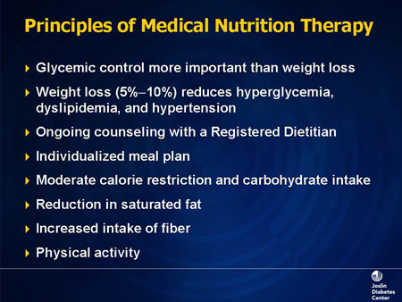
Slide 18. Principles of Medical Nutrition Therapy
Medical nutrition therapy forms a large part of this education, and there are a number of goals. Weight loss does not have to be overwhelming to reduce hyperglycemia or other macrovascular risk factors. A reduction of about 5% to 10% of body weight has substantial metabolic benefits. Patients are not always happy with a 5% weight loss; their goals are sometimes more cosmetic or social. But metabolically, even that amount of weight loss will be very beneficial.
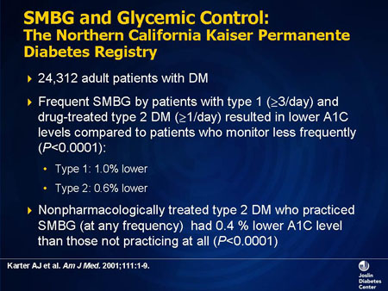
Slide 19. SMBG and Glycemic Control: The Northern California Kaiser Permanente Diabetes Registry
Self-monitoring of blood glucose is equally important. Not many studies have looked at this, but this was a very good study from Kaiser Permanente Health System of roughly 24,000 patients. Patients who monitored blood glucose at home had better A1Cs; in type 1 patients, it was about 1% lower and in type 2 patients, it was about 0.6% lower. Individuals who practiced self-monitoring of blood glucose with any frequency had some statistically significant lowering of A1C. Working with patients to impart the meaning of their blood glucose can make this is a very useful technique.
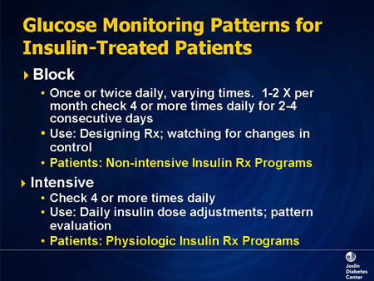
Slide 20. Glucose Monitoring Patterns for Insulin-Treated Patients
There are many different patterns for testing blood glucose. Patients can do "block testing" once or twice daily. If they do it once daily, sometimes we will tell them to do fasting glucose one day and postprandial the next day. Or we may rotate postprandial blood glucose in combination with fasting; a patient will be testing fasting glucose one day, 2 hours after breakfast the next day, 2 hours after lunch on the next day; and 2 hours after dinner on the next. Over a period of time you can develop a grid that yields good information while testing only once a day.
There are more intensive ways of approaching this, such as having patients check their blood glucose 4 or more times daily. This can be used to determine patterns that will help adjust patient insulin programs.
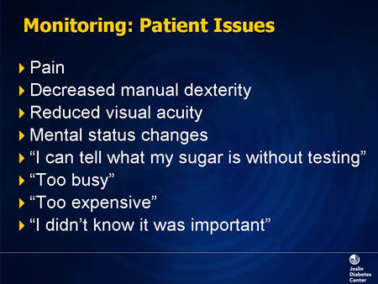
Slide 21. Monitoring: Patient Issues
There are issues with self-monitoring. It causes pain in some patients more than others. Some patients do not have the manual or visual skills to be able to accomplish self-monitoring. There may be issues with cognitive function. We have to work with those patients, and the educators do a great job. There are also a number of different meters, which tend to work better for one type of patient than the other.
Then we have the excuses that patients give us as to why they do not want to do testing, which do not have anything to do with physical issues. But they are, nonetheless, real-life issues, particularly the expense.

Oral Agents for Diabetes Treatment
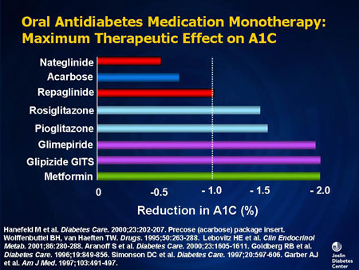
Slide 22. Oral Antidiabetes Medication Monotherapy: Maximum Therapeutic Effect on A1C
In terms of oral therapy, we have a number of tools. The medications we tend to use the most are the ones capable of conveying a 1% to 2% reduction in A1C, either as monotherapies or as add-on therapies. Remember that the degree of reduction in A1C is going to be conditioned by the A1C at which the patient starts treatment; the lower the A1C at baseline, the smaller the decrease in A1C that is likely to occur with the addition of a therapy. All of these medications are good as monotherapies or in combination, with the obvious exception of using 2 insulin secretagogues together or 2 thiazolidinediones (TZDs) together. But each class of drugs is effective as a mono- or combination therapy.
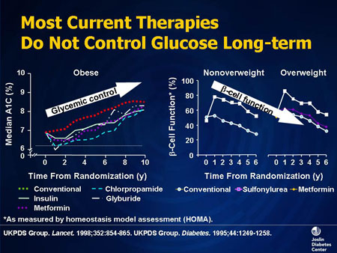
Slide 23. Most Current Therapies Do Not Control Glucose Long-term
During the early years of the UKPDS, all study arms were effective in lowering A1C, whether insulin, metformin, or a sulfonylurea was the treatment modality. But as time went on, there was a decline in glycemic control. Not surprisingly, this was associated with a decrease in beta-cell function. The implication is that most patients end up using combination therapy, similar to the way in which hypertension and dyslipidemia are treated.
Numerically, the rise in A1C was about 0.2% to 0.3% per year despite being on a given monotherapy, and is much the same whether the result of diet failure, sulfonylurea failure, or metformin failure. All treatment groups experienced failure at more or less the same rate, and the decline in beta-cell function was also approximately the same for all of them. As such, combination therapy is routinely needed.
In addition, if your patient has been on combination therapy (2 agents) that is inadequate, you could add a third oral agent, exenatide or insulin. A number of insulins are available: long-acting basal insulin; premixed insulin (70/30, 75/25); and prandial insulin coverage, the latter being short- or extremely short-acting insulins that target postprandial blood glucose.

Insulin Therapy for Diabetes
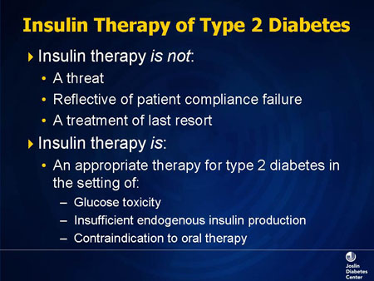
Slide 24. Insulin Therapy of Type 2 Diabetes
Insulin therapy is not the course of last resort. Many patients view it as the end of the road for their diabetes. Of course it is not that, it is just a tool for controlling blood glucose. But many patients have heard that their parents or their grandparents got insulin just before they died, their kidneys failed, or they had an amputation. Insulin is an appropriate therapy for any patients who have not reached targets by other means.
I used to think that people did not like the idea of injections. But then I realized that injecting insulin is not as uncomfortable as self-glucose monitoring. Exenatide, which is an injectable administered twice a day, comes with the promise of weight loss, and suddenly it becomes very acceptable. Although there are occasional patients who are truly phobic, the fear of injections is not as widespread as we once thought it was.
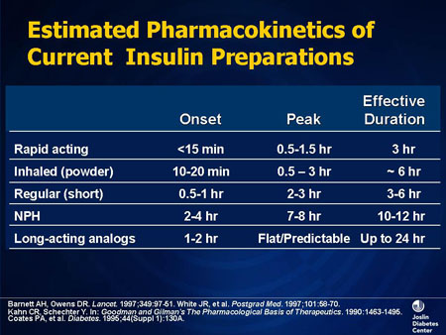
Slide 25. Estimated Pharmacokinetics of Current Insulin Preparations
What types of insulin are available? There are rapid-acting insulins that begin to work in about 15 minutes, and peak somewhere between 1 and 2 hours. Examples of such rapidly acting insulins are insulin lispro, insulin aspart, or insulin glulisine. These are very appealing insulin choices because they have a quick onset of action, and their peak action tends to coincide with the time that postprandial glucose levels are at their peak.
In addition, we have inhaled insulin, which is also quick-acting. Regular insulin pharmacokinetics are similar to the rapid-acting insulins, but with some significant time course differences. There are also intermediate-acting insulins, such as neutral protamine Hagedorn (NPH), which has a peak 7 to 8 hours after you take it. The longer-acting analogs, such as insulin glargine or insulin detemir, are "24-hour" insulins.
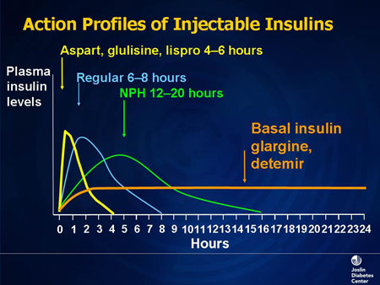
Slide 26. Action Profiles of Injectable Insulins
This schematic gives you the profiles for injectable insulin. The longer-acting insulins, such as glargine(Lantus) or detemir(Levemir), are theoretically 24-hour insulins; they have a duration of action of about 24 hours, and they tend to mimic basal insulin levels.
In terms of shorter-acting insulins, we have the rapid-acting ones, aspart(Novorapid), glulisine(Apidra), or lispro(Humalog), which have a fairly rapid peak of onset, but their effect is dissipated fairly quickly, in a few hours. The rapid dissipation of these insulins results in less hypoglycemia but also can leave a void in insulin activity in some patients between meals. NPH has a significantly longer profile.
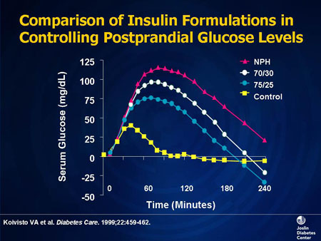
Slide 27. Comparison of Insulin Formulations in Controlling Postprandial Glucose Levels
If one examines the glucose profiles over a period of 4 hours in nondiabetic controls and in individuals given either glucose and NPH, a mixture of 70% NPH/30% regular, or 75%/25%, (a mixture of an NPH-type insulin with a short-acting insulin, either lispro or aspart), the insulins that have a quicker onset tend to suppress the rise in postprandial glucose to a greater degree.
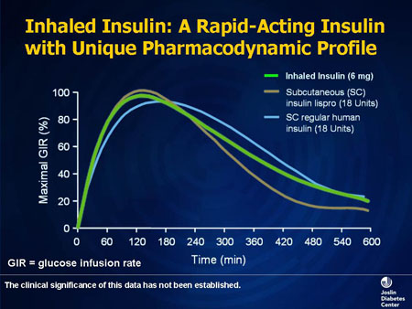
Slide 28. Inhaled Insulin: A Rapid-Acting Insulin With Unique Pharmacodynamic Profile
Inhaled insulin fits in between the more rapid-acting insulins, in this case lispro or regular. In terms of the onset of action, it is rapid, close to the more rapid-acting insulin, but it is not gone quite as quickly, which is more like regular. So, to a certain extent, you get some of both when using the inhaled insulin.
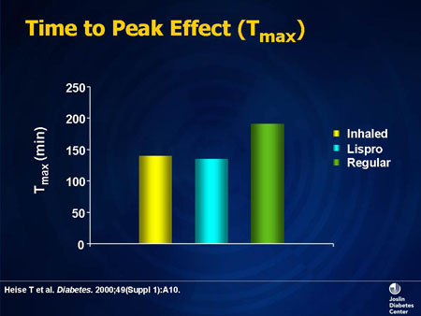
Slide 29. Time to Peak Effect (Tmax)
This is a more quantitative bar graph of the time to peak effect of these 3 insulins. And you can see, when viewed in this format, the inhaled insulin is more like the rapid-acting insulin, lispro, than it is like the regular insulin.

Insulin Effects on A1C
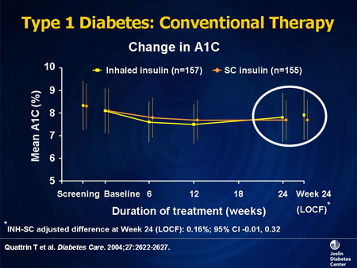
Slide 30. Type 1 Diabetes: Conventional Therapy
Many studies have compared the effect of inhaled insulin to subcutaneous insulin. This is a 6-month study in which type 1 diabetes patients either receive subcutaneous insulin or inhaled insulin as part of their program. As shown, there was essentially no difference in A1C at the end of 6 months between the two groups.
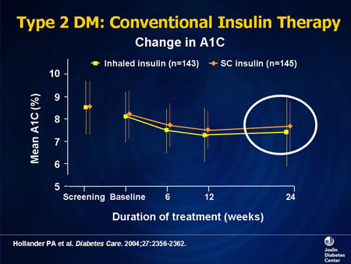
Slide 31. Type 2 DM: Conventional Insulin Therapy
This is a study of type 2 diabetes patients being treated either with subcutaneous insulin or inhaled insulin. Again, at the end of 6 months, there is essentially no difference in A1Cs.
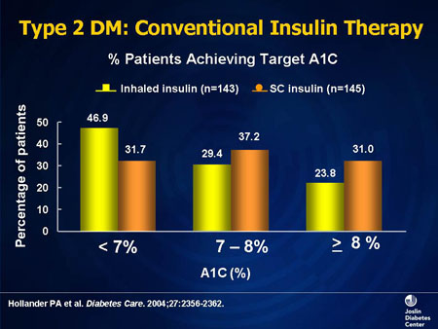
Slide 32. Type 2 DM: Conventional Insulin Therapy
If you compare inhaled insulin with subcutaneous insulin in terms of percentage of patients who reached some predetermined A1C goal, more of the patients on inhaled insulin got to a target of less than 7% than those on subcutaneous insulin.
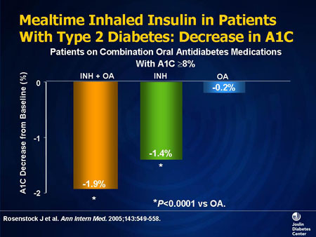
Slide 33. Mealtime Inhaled Insulin in Patients With Type 2 Diabetes: Decrease in A1C
These data show decreases in A1C in patients who are being treated with combinations of oral agents, with inhaled insulin, or both. These patients all qualified for the study because they had been on combinations of an insulin sensitizer, either metformin or a TZD, plus a secretagogue such as a sulfonylurea. In those in whom no therapy change was made, there was no further decrease in A1C. In patients taken off the combination and started on inhaled insulin, an A1C decrease of 1.4% was seen. If left on oral agents and adding inhaled insulin, the largest decrease of 1.9% occurred.
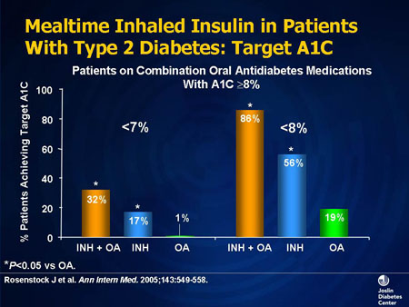
Slide 34. Mealtime Inhaled Insulin in Patients With Type 2 Diabetes: Target A1C
This study involved stratification according to the achievement of predetermined targets for A1C in that same group of patients, i.e., patients maintained on oral agents, switched to inhaled insulin, or combining the two. A larger percentage of patients reached a target of either less than 8% or less than 7% with the combination of inhaled insulin and oral agents.

Safety With Inhaled Insulin: Adverse Events and Pulmonary Safety
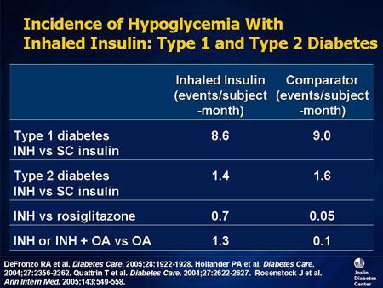
Slide 35. Incidence of Hypoglycemia With Inhaled Insulin: Type 1 and Type 2 Diabetes
There are adverse effects with every drug and inhaled insulin is no exception. The most commonly reported side effects in clinical trials were hypoglycemia, a type of chest discomfort, cough, and dyspnea.
As with every type of insulin, hypoglycemia is the most frequent adverse event that is reported in trials. The incidence of hypoglycemia in trials was comparable in the inhaled and subcutaneous insulin groups. When compared with oral agents, some of which do not even cause hypoglycemia, obviously hypoglycemia was more common in the patients who took inhaled insulin.
In a numerical comparison of the incidence of hypoglycemia in patients with type 1 diabetes receiving either inhaled or subcutaneous insulin, there is roughly the same incidence in both groups; in patients with type 2 diabetes, similar results were seen. The biggest differential was in patients who were taking inhaled insulin plus oral agents vs the oral agents alone. Remember, these patients had failed on oral agents, were therefore not as close to hypoglycemic levels, and received no additional intervention.
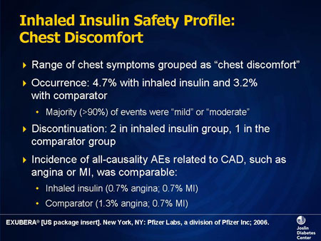
Slide 36. Inhaled Insulin Safety Profile: Chest Discomfort
Chest discomfort is a vaguely described group of symptoms that patients often report when they have taken inhaled insulin, with about 5% incidence in the trials. Most of the patients classified it as either mild or moderate. There were few patients who discontinued therapy because of this particular sensation, and there was not any increase in reported ischemic cardiac adverse events in the inhaled insulin group.
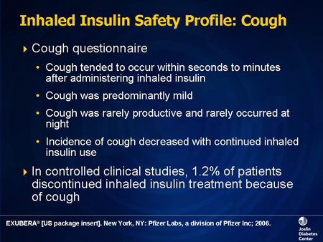
Slide 37. Inhaled Insulin Safety Profile: Cough
Cough was another symptom that occurred with enough frequency to draw attention. It tends to occur early, soon after the insulin is inhaled, is characterized as relatively mild, and is associated with some but relatively modest sputum production. There was a tendency for patients to develop some tolerance to this symptom. Overall, in the clinical trials, slightly over 1% of patients discontinued specifically because of the cough.
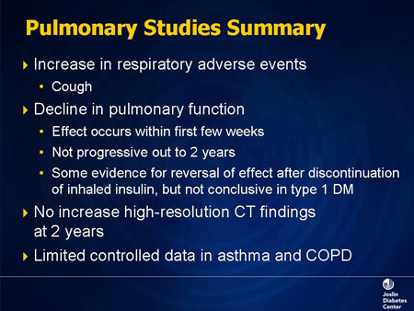
Slide 38. Pulmonary Studies Summary
The reasons for paying attention to pulmonary safety with an inhaled drug are obvious. It will be chronically administered, is a growth-promoting factor, and can stimulate immune responses, systemically and locally. Therefore, it is important to pay attention to patients receiving inhaled insulin and to symptoms that may develop.
Pulmonary studies generally have shown a small decline in some aspects of pulmonary function. It is usually recommended to do a pulmonary function test both before and 6 months after you start the inhaled insulin. If a decline from baseline of over 20% in any pulmonary function test is seen, the dose of inhaled insulin should be decreased or the drug discontinued altogether. No anatomic findings were noted on computed tomography scanning.
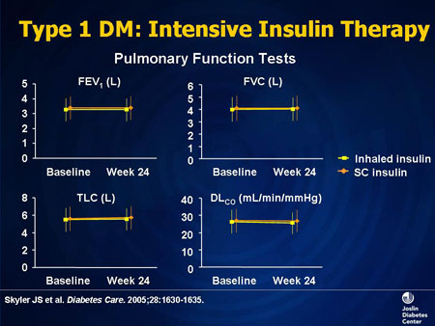
Slide 39. Type 1 DM: Intensive Insulin Therapy
These data represent pulmonary function tests in patients on inhaled vs subcutaneous insulin. In this study of these specific parameters of pulmonary function over a 6-month period, no major change was noted.
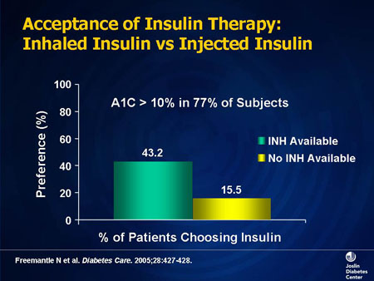
Slide 40. Acceptance of Insulin Therapy: Inhaled Insulin vs Injected Insulin
Patient acceptance of inhaled insulin is very good, since most patients who gravitate towards this modality do so because they do not like self-administered injection. It has been well received in those studies that have addressed this issue.
Insulin Therapy

Use of Insulin in Type 1 and Type 2 Diabetes
Having reviewed the pathophysiology of diabetes and the tools to treat it. We will walk through some of the mental processes we go through when we initiate insulin therapy, how we make those decisions, and how we try to maintain an effective insulin treatment program.
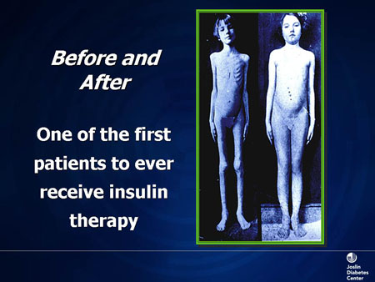
Slide 1. Before and After
The discovery of insulin in 1921 was a quantum leap for patients with diabetes. Without insulin, this young girl would have died in a matter of days or weeks. Insulin is life-saving in type 1 diabetes.
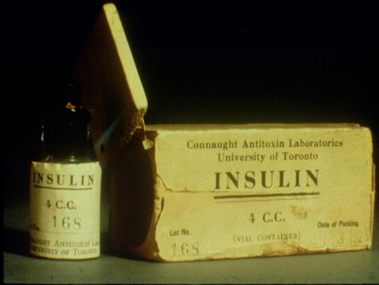
Slide 2. Early Extract of Insulin
With the use of insulin, we have made tremendous strides. This is a vial of the earliest extract of insulin from the University of Toronto, Ontario, Canada. There has been great progress made in terms of purification, from an animal source-based insulin to the current era of "designer insulins," as well as changes in the routes of administration.
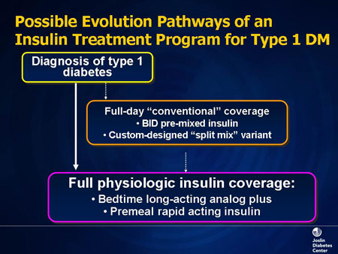
Slide 3. Possible Evolution Pathways of an Insulin Treatment Program for Type 1 DM
For a patient with type 1 diabetes more than 35 years ago, we used a more conventional approach, which was a split mix; it was either lente or neutral protamine Hagedorn (NPH) with regular insulin, twice daily. We varied that and did urine testing. Today, if we see a patient with type 1 diabetes, we almost immediately use basal/bolus therapy. The physiologic insulin replacement is the closest we have to mimicking normal physiology. And unless that patient is going through a remission, invariably this is where he or she will end up.
What varies today is the delivery route. For some patients, it may be a subcutaneous insulin infusion pump, and for others it will be basal/bolus insulin injections or inhaled insulin available as a prandial insulin option.
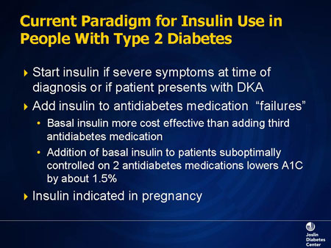
Slide 4. Current Paradigm for Insulin Use in People With Type 2 Diabetes
The type 2 diabetes paradigm is still evolving. In general, the pathophysiology of type 2 diabetes results in a defect in insulin secretion as well as in insulin action. The natural history has been a progressive decline in beta-cell function, leading to greater and greater need for insulin replacement therapy as a supplement.
In some instances, a patient with type 2 diabetes will start with insulin. This may be an individual who is symptomatic or losing weight. Or, some type 2 diabetes patients may present with ketoacidosis, recover, and be able to be controlled once again on oral therapy. But the traditional scenario is that our patients have gone through oral medicines and are no longer adequately controlling the blood glucose levels to goal. In this instance, we initiate therapies with insulin.
The traditional model has been evolving to where we would introduce a basal type of insulin based on an understanding of the pathophysiology that as insulin secretion decreases, hepatic glucose production rises, and therefore fasting glucoses rise. So using a nighttime dose of insulin would suppress the liver's output of glucose and lower the fasting level. In general, this is a very effective therapy and is probably better than using 3 drugs; triple oral agents, at best, may lower A1C by 1%. In addition, any woman who is pregnant and has diabetes will be on insulin.
Another question that keeps coming up, which I think is becoming even more of an issue, is the role of postprandial hyperglycemia, not only in terms of microvascular disease, but also the potential role either the hyperglycemia or the posthyperglycemic metabolic state may contribute to cardiovascular risk. Another question is whether there is a place in our strategies for using prandial insulins earlier. In order to get A1C to less than 7%, you have to lower both fasting and postprandial glucose. But there are instances when patients may have, predominantly, a single peak in a postprandial glucose that you target. But you are going to base that decision on the glucose profile from glucose monitoring, and then adapt the tools that will work best.
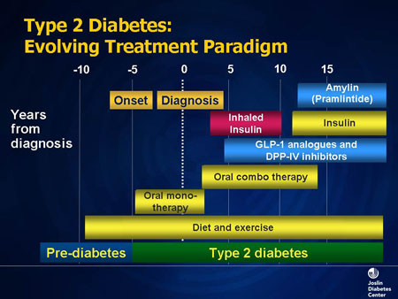
Slide 5. Type 2 Diabetes: Evolving Treatment Paradigm
Reviewing the therapies, it does not matter whether patients take insulin or oral medicines; you cannot escape the fact that diabetes is a disease that has to do with food, eating, and insulin production. In general, the traditional model was to start with diet and exercise, then wait to use an oral medicine.
The most current guidelines suggest that we start with an oral medicine and diet and exercise together, and the drug that the Canadian Diabetes Association (CDA) has recommended in that scenario is metformin. Then if one drug does not work, we add another, and in some instances we will add even a third one. This has been the paradigm, and when that did not work and you notice that now we are up to over 10 years from the diagnosis, then insulin would be added, if it was added at all. The new CDA guidelines recommend adding insulin much earlier in the treatment to avoid this delay.
That scenario has changed because therapies in the toolbox are increasing. Now we have the glucagon-like peptide-1 (GLP-1) analogs that you heard mentioned, wonderful therapies that have taken away the issue of "I do not like shots," and the dipeptidyl peptidase-IV (DPP-IV) inhibitors, a clear example of understanding pathophysiology and then devising a therapeutic strategy that works.
For those patients on insulin for whom you wanted to control postprandial hyperglycemia and you have tried with regular insulin or a rapid-acting insulin analog with nutritional manipulations, pramlintide, which is an analog of amylin, is a very good postprandial glucose-controlling agent, suppressing glucagon levels and improving postprandial glucose. It can only be used with insulin therapy. The latest therapy is inhaled insulin, it is a prandial insulin; it is not a basal insulin and it is not to be used that way.

Insulin Therapy: Obstacles, Barriers, Challenges
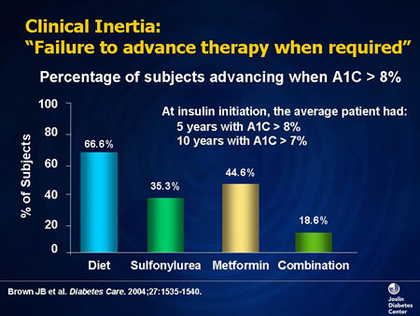
Slide 6. Clinical Inertia: "Failure to advance therapy when required"
One thing is clear: we seem to have a problem, and it is clinical inertia. We have this disease that is progressing, yet we seem to be standing still in making our decisions, and it is not because of a lack of tools.
This study came out of the Kaiser Permanente group in California. They looked at how many patients moved to the next level of treatment when A1C was over 8%. Of patients taking sulfonylureas, only 35% went to the next stage, which would probably be a combination of 2 pills. If patients were on metformin, 44% had another treatment. But when patients were on 2 drugs, only 18% went to the next step, because the next step is insulin. In general, patients spent 5 years with an A1C over 8% before a decision was made. That is unacceptable, certainly from the patient's point of view. We need to be much more proactive as we understand the pathophysiology of diabetes.
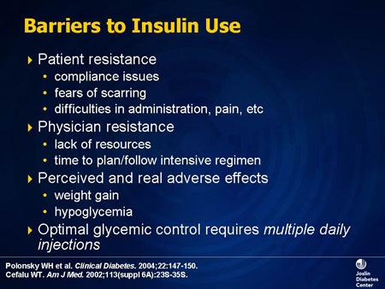
Slide 7. Barriers to Insulin Use
There are barriers to insulin use. There are patient issues; we call this "psychological insulin resistance." However, the needles today are very fine; self-glucose monitoring is far more painful. But patients have this idea that shots will scar them, and they are going to be painful.
Practitioners are very busy. When we use insulin therapy, we start at one point and we may end up at a very complex place, using intensive therapy, which is time-consuming, requires staff, and requires a lot of input. When you use multiple daily injections (MDI) or intensive therapy, someone has to be on call to treat these patients. Consequently, available resources sometimes determine the steps we take.
We also know that patients are very savvy. They know that insulin causes you to gain weight. Why do you think the use of GLP-1 analogs is going up so fast? They control blood glucose, and you lose weight at the same time.
Hypoglycemia is very real. If you have experienced hypoglycemia, all you can think of is food. It is not a nice feeling.
And finally, I think we recognize that for optimal control of diabetes we should be prepared to use multiple injections. One of the things we never do is to promise our patients that there will only be 1 shot a day. It is going to be as many shots as it takes.
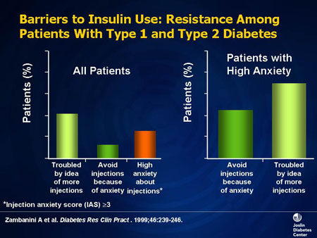
Slide 8. Barriers to Insulin Use: Resistance Among Patients With Type 1 and Type 2 Diabetes
This study was published in 1999. Zambanini and colleagues assessed type 1 and type 2 patients to determine some of the reasons for this resistance. People are troubled by the idea that they may take more than 1 shot per day. They do not like the insulin injection; there is anxiety about sticking themselves. Even when they took the patients who were very anxious, whom we would think do not want to take insulin at all, their major concern appeared to be whether they would end up with more than 1 daily injection. But if the "return" for using that treatment is good, patients overcome that barrier.
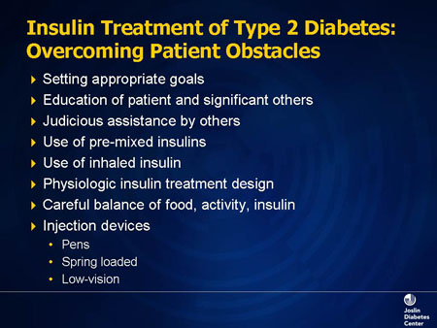
Slide 9. Insulin Treatment of Type 2 Diabetes: Overcoming Patient Obstacles
Providers have to overcome these obstacles. We have to set very appropriate goals for our patients, individualizing the approach. Education of the patient and others involved in their care is very, very important. The advent of premixed insulins has been very helpful for those select patients who require good control, but not necessarily getting A1Cs to 7% or less.
We will discuss inhaled insulin. Certainly, at the back of our mind, our strategy is always to try and mimic normal physiology. And there have been great advances in terms of the insulin syringes, from the days of glass syringes boiled to maintain sterility. Today insulin is available in pen devices. It costs a little more, but they are portable, and often these pens have easy-to-see dials. People who may have visual issues can hear the clicks.

Considering the Next Steps in Insulin Therapy
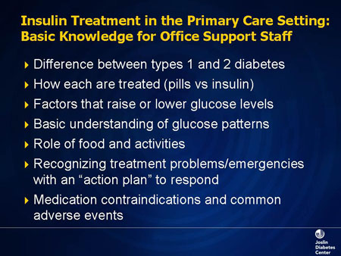
Slide 10. Insulin Treatment in the Primary Care Setting: Basic Knowledge for Office Support Staff
When I was practicing at the Joslin Diabetes Center, I could send the patient to the nurse practitioner, dietician, nurse educator, exercise physiologist, or psychologist; you name it, we had it. But what do you do in your own office practice?
Diabetes is a great example of a team approach, and the people may be in your office, or they may be in the community. As the provider, you need to identify those resources. If you have someone in your office who is taking on a support role and will be liaising with patients, they need to be knowledgeable about the differences between type 1 and type 2 diabetes, why we choose different therapies, and what factors raise and lower glucose. They need to look at glucose patterns. We are asking patients to test their blood glucose, and the worst thing to do is not to review them when they bring them to us; otherwise it is a useless exercise. So knowing how to interpret glucose patterns is very important. Support staff also should be educated in the role of different types of food and their effect, exercise, etc., and how to respond to emergencies. This type of education is very important.
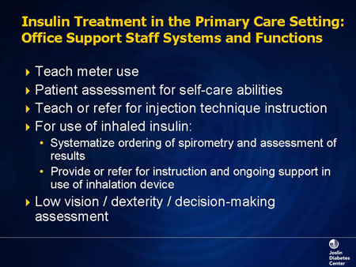
Slide 11. Insulin Treatment in the Primary Care Setting: Office Support Staff Systems and Functions
Furthermore, in many of these situations you may rely on your nurse to teach meter use, and that would involve determining the patient's ability to participate in their care. Diabetes is a self-management disease, and you need to assess the patient's self-care ability, and then involve other appropriate caregivers if necessary.
Knowing how to inject insulin is very important. Every patient has to learn how to inject insulin if they are taking insulin, even if it is inhaled, because a device may malfunction and may require them to use injection instead. It is similar to patients on an intermediate-acting insulin once a day; we also provide them with a vial of rapid-acting insulin that may be necessary for emergencies. With inhaled insulin, there will be a new challenge for us regarding lung function, which is a critical part of using this current tool.
If you decide that the patient needs to go to the next step, what are some of the factors to consider in making these choices? You want to balance the treatment goals with the medical needs of patients, and have a very holistic approach to other conditions, other comorbid diseases. Safety is always of primary importance. We would also like as flexible a program as we can devise, and we want a good assessment of the patient. We ask how they will interact with us in this program: Can they make the judgments that will be required for some of these sophisticated tools?
Psychosocial and cultural issues are very important. We have to take them in context, because they influence the kind of healthcare beliefs patients grow up with and their expectations. Physical and mental limitations may also come into play.
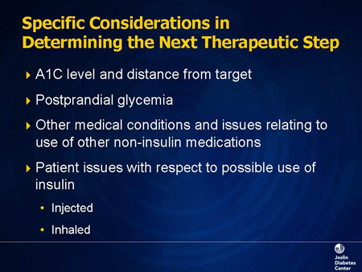
Slide 12. Specific Considerations in Determining the Next Therapeutic Step
In terms of determining what therapeutic tool you are going to use, one of the most important assessments is glycosylated hemoglobin (A1C). If you see a patient who has had 5 or more years of type 2 diabetes, is on two drugs, and their A1C is 10% or 12%, it is not coming down to 7% with another drug; if A1C is 8%, you can probably get it down to 7%, with a third drug. So the level of A1C is very important, especially with longer-duration diabetes. Early in the disease, when it is newly diagnosed, the higher the A1C, the bigger the decrease with initial treatment but this changes with time as beta-cell insulin secretion decreases.
Postprandial hyperglycemia has to be monitored, and is a target for control. The current level set by the CDA is less than 8 mmol/L (140 mg/dL).
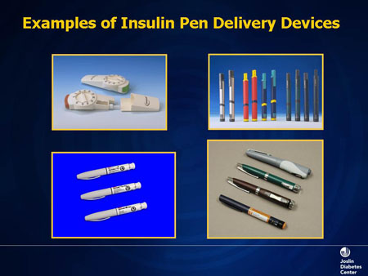
Slide 13. Examples of Insulin Pen Delivery Devices
There are a variety of insulin pens available, and these are wonderful tools to use. Some of them even come with little meters attached. So you carry this with you, test your blood glucose, decide what you are going to eat, put in the fast-acting insulin, come home, and take your basal insulin. There is a great deal of portability as well as flexibility available to our patients today.

Consideration in Use of Inhaled Insulin
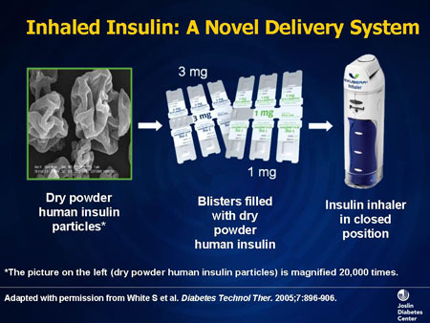
Slide 14. Inhaled Insulin: A Novel Delivery System
What about inhaled insulin? Ever since the initial discovery of insulin and its purification, patients have been trying to avoid injections. Insulin was initially used 4 times a day. Then they developed protamine zinc insulin, which was given once a day. It took the Diabetes Control and Complications Trial (DCCT) to bring us full circle, back to 4 shots a day, because this offered the best control.
There is also a constant quest to find alternate routes of administration. Investigators looked at drops in the eyes, rectal administration, nasal insulin, dermal patches, and oral insulin. The one that became the primary target was inhalation of insulin, because there was precedent for this approach; patients inhale many different drugs (bronchodilators, steroids).
The lung is a very vascular bed, and when appropriate particle-size medication gets into the lung, it is very rapidly absorbed into the circulation. So it was natural that people would look at this route of administration for insulin.
The only inhaled insulin that is approved in Canada is Exubera (insulin human [rDNA origin]) Inhalation Powder. Being the only approved inhaled insulin, more data have been collected on this particular medication than on any others at this time.
In preparation for the evolution of this class, it is important to distinguish here between data that are specific to the approved product, Exubera, and data that are general to the class. As other products become approved, these distinctions could be extremely important. Therefore, to clarify for you and because the generic terminology is not clear at this point in time, I will use the term "Exubera" when data are specific to this inhaled insulin product. "Inhaled insulin" is used when referring to the general class of insulin via the inhalation route.
Exubera (human insulin [rDNA origin]) inhalation powder uses particles that are between 1 and 5 microns in diameter, the optimal size for inhalation. Other forms in development include AERx (NovoNordisk), AIR (Lilly), Spiro (Dura), Technosphere Insulin (MannKind), and Aerodose (Aerogen). Some are not powder but aerosol. Their excipients and medication delivery systems also differ.
Exubera (human insulin [rDNA origin]) inhalation powder is packaged in a blister pack. For the first time, insulin, which we usually talk about in units, is being presented to us in milligrams. You have a 1-mg pack, which has 3 units of insulin, and a 3-mg pack, which has 8 units. The blister pack is placed in an inhalation device.
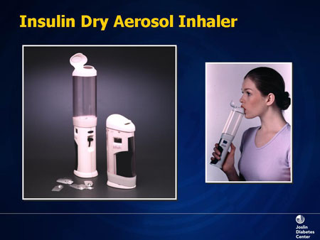
Slide 15. Insulin Dry Aerosol Inhaler
The blister pack goes in the chamber, and there is a handle that the patient squeezes, which increases compressed air in the chamber, the insulin is aerosolized, and then the patient puts the inhaler in their mouth and inhales for about 5 seconds, and then releases the handle. If using multiple doses, you have to keep repeating that process. Other devices exist. Some are smaller, and some have electronic chips that activate at the correct time; if the patient tries to hold their breath, it will not work.
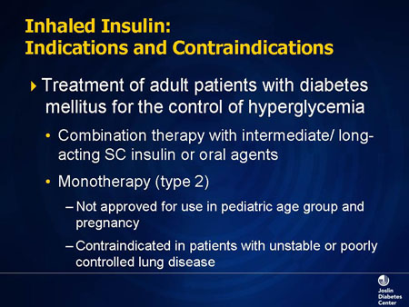
Slide 16. Inhaled Insulin: Indications and Contraindications
The indications for Exubera are similar to any prandial insulin. It is for the treatment of adults with diabetes when other methods have not controlled their hyperglycemia. In the type 2 diabetes population, you can combine this with oral medicines, or you can us must be used e it as monotherapy. In a type 1 diabetes population, it replaces the prandial injection, but must be used together with basal insulin. It is not approved for use in pregnancy or pediatric patients at the present time. A big factor is that it is contraindicated in patients with unstable or poorly controlled lung disease, and there are some interesting issues around the absorption of insulin in these circumstances.
When they studied the pharmacokinetics of Exubera, age, gender, race, and body mass index do not seem to have an effect. The only difference is that the heavier patients may require more insulin if they are insulin resistant. Very interestingly, smoking increases the absorption rate, although cigarette smoking is an absolute contraindication. The bioavailability of Exubera is much higher with chronic lung disease, but lower with asthma. We do not have data to know why, except to say that this is being studied progressively as more patients use the product. And it is comparable in peak action to analog rapid-acting insulin such as lispro. However the duration of action is more like regular insulin.
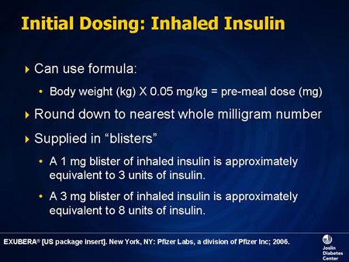
Slide 17. Initial Dosing: Inhaled Insulin
How do you dose Exubera inhaled insulin? You can use a formula: you administer .05 mg/kg of body weight, which is your premeal dose. And you have to round up to the nearest whole number.
As I mentioned, blisters are produced as 1- and 3-mg packets. So you do not want to allow a patient who is taking a 3-mg blister based upon your calculation to take three 1-mg blisters because they will be getting 9, not 8, units of insulin. In general, that may not be important, but for type 1 diabetes patients, 1 unit can be very important; so you have to be careful.
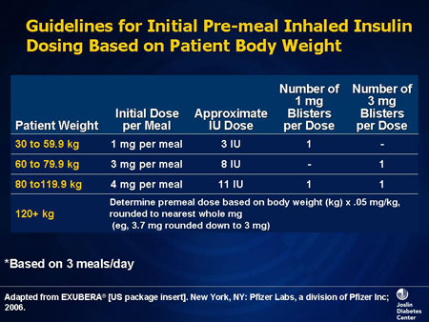
Slide 18. Guidelines for Initial Pre-meal Inhaled Insulin Dosing Based on Patient Body Weight
Another approach, if you know the weight of your patient, is in the Exubera package insert. They recommend an initial dose of inhaled insulin per meal. So if the patient weighs 80 kg, they will require 4 mg for that meal, which is about 11 units. How do you get 11 units? You take 1 of the 3-mg blisters and 1 of the 1-mg blisters. And patients would have to administer each of these blisters separately. This is the current approach.
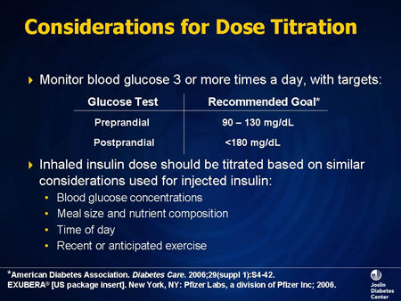
Slide 19. Considerations for Dose Titration
If one has started an insulin program, glucose monitoring becomes very important, and we have targets that need to be reached. If using inhaled insulin, it is titrated like any other prandial insulin. All of the traditional factors, the glucose concentration, the meal size, the composition, the carbohydrate content, the glycemic index, the time of the day, exercise, etc., are considered. You will make the same assessments and then adjust the dosage.

Pulmonary Assessment During Inhaled Insulin Therapy
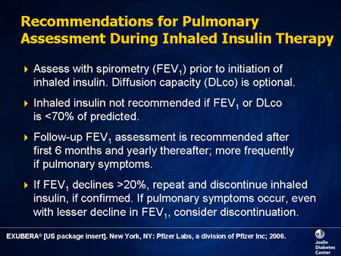
Slide 20. Recommendations for Pulmonary Assessment During Inhaled Insulin Therapy
There are some very strict guidelines for pulmonary assessment. Every patient to be put on Exubera must have spirometry done. Who is going to do the test? What do you do in your office? Contact the local hospital to have the test done or if you are going to do it in your office, you need to make sure that you are proficient with spirometry and what the standardizations are, the interpretation of which cannot vary from patient to patient. Diffusing capacity of the lung for carbon monoxide (DLCO) is an optional assessment that you generally will not need to do.
We measure the forced expiratory volume in 1 second (FEV₁). If the FEV₁ is less than 70% of predicted, you cannot use Exubera. The guidelines for use also recommend a 6-month follow-up test, and yearly or more frequently if indicated. For instance, if a patient's cough has not disappeared, you might want to repeat it. If there is a decline in pulmonary function while the patient is on the insulin and if FEV₁ declines more than 20% (or more than 500 mL in volume), then repeat the test. If it is still the same, stop the insulin. If a patient is very symptomatic in other ways, with chest discomfort and just not feeling right, you may have to discontinue inhaled insulin under those circumstances.
Contraindications include hypersensitivity to inhaled insulin itself. Smokers or patients who have stopped smoking within 6 months should not be on inhaled insulin. If the patient resumes smoking, you have to discontinue the inhaled insulin immediately.
In terms of unstable and poorly controlled lung disease being a contraindication, the reason for this is there may be variation in the absorption of the insulin. Although we do not know exactly what is meant by unstable or poorly controlled lung disease (for example, patients with chronic obstructive pulmonary disease, asthma, etc.), it would be prudent at the present time to not consider those patients as candidates for inhaled insulin.
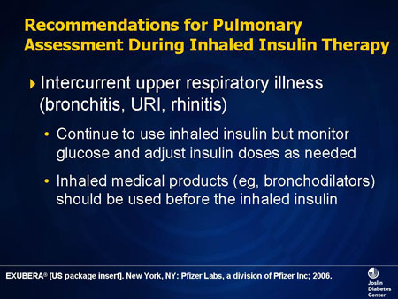
Slide 21. Recommendations for Pulmonary Assessment During Inhaled Insulin Therapy
What if patients develop an upper respiratory tract infection, mild cold, or a little bit of bronchitis? You can continue the insulin but monitor glucose. What if they have pneumonia? Chances are you should stop it. And if they are using bronchodilators, they should be used first and the inhaled insulin should be given secondarily.

Designing an Insulin Treatment Program: Basal Insulin
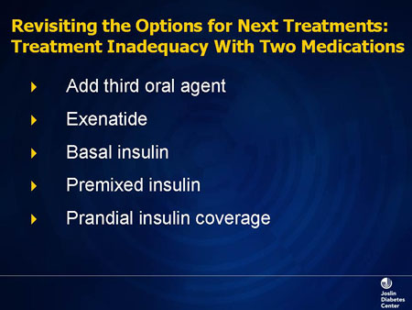
Slide 22. Revisiting the Options for Next Treatments: Treatment Inadequacy With Two Medications
We have the option of adding a third oral agent, whether it is a sulfonylurea, a DPP-IV inhibitor, or exenatide. We are going to focus on how we move through this cascade. When do we use basal, when do we use premix, and how do we achieve basal/bolus coverage?
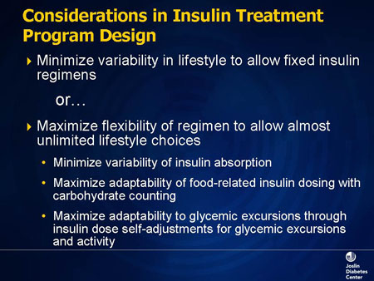
Slide 23. Considerations in Insulin Treatment Program Design
When you see a patient with diabetes, you have to decide the kind of program to design for this individual. Young business executives who are on the go want flexibility in terms of the shots, their travel, etc. That means choosing a program that is most flexible.
On the other hand, the choice may be to minimize the fluctuations and the variability of insulin absorption. There are patients who can be initiated on this type of program, but cannot stay there if the situation changes. You can start with one injection, but if things change, be prepared to add on to that. Where you start determines where you go.
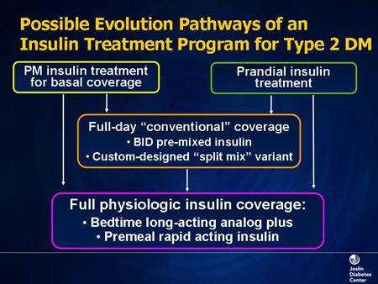
Slide 24. Possible Evolution Pathways of an Insulin Treatment Program for Type 2 DM
What are the possible pathways for the evolution of an insulin treatment program for type 2 diabetes patients? One is PM insulin basal coverage (giving some insulin at night). If that does not work and postprandial glucoses go up early in the day, we would move to the split-mix approach. Today, much as in type 1 diabetes, we would offer preprandial insulin to patients who are developing postprandial hyperglycemia. That does not necessarily mean three injections or three inhalations of insulin per day for a patient with type 2 diabetes. Glycemic excursions will determine at what point you initiate preprandial insulin. Some patients may need it once; some may need it twice.
Prandial treatment currently has been using rapid-acting insulins; glulisine, lispro, and aspart. Today, inhaled insulin comes in that cascade and will be part of treatment either as an add-on or part of a basal/bolus treatment.
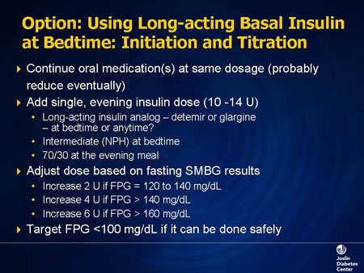
Slide 25. Option: Using Long-acting Basal Insulin at Bedtime: Initiation and Titration
Assume you have a patient on two drugs. You want to start insulin, and you have chosen basal insulin because of fasting hyperglycemia. The first principal: this is add-on therapy. The oral agents stay at their current doses; no adjustments are made. You add a single dose of an insulin. This could be a long-acting basal insulin (detemir, glargine) or NPH, an intermediate-acting insulin analog, at bedtime. Insulin glargine and detemir can be used at other times but the same time daily. If the patient has postmeal hyperglycemia after dinner, perhaps a 70/30 or analog mix may be used.
The physician then follows an adjustment algorithm. You need to make these adjustments weekly to get your patient to target, remembering that in a type 2 diabetes patient, you may end up with 40 to 50 units of a single type of insulin in order to control hyperglycemia in the fasting state. In selected patients, you can have them monitor and make adjustments every 2 or 3 days, which expedites the process. The target is to reduce fasting glucose to less than 5.5 mmol/L (100 mg/dL), if it can be done safely.
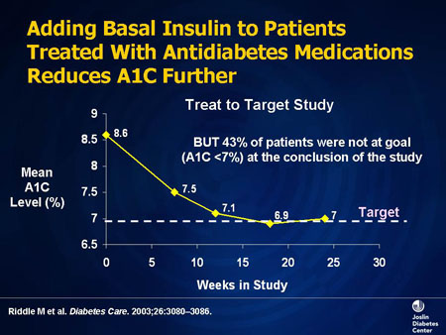
Slide 26. Adding Basal Insulin to Patients Treated With Antidiabetes Medications Reduces A1C Further
Studies have been conducted to look at basal insulin vs intermediate-acting insulin. This is a treat-to-target study, where glargine is compared with NPH in a group of patients not controlled on oral medicines. Both insulins lowered A1C from 8.6% to 7.1% in about 3 to 4 months, a very nice drop, and they required roughly equivalent doses. The difference in the study was that with glargine, there was a little less nocturnal hypoglycemia than with NPH. So for a purely fasting target, this type of an approach is a very good one.
But in this treat-to-target study, 43% of the patients were not at an A1C goal of less than 7%. So the question is: where is the escape occurring? If the fasting glucose is looking good and A1C is not coming down, where is the next problem? As A1C comes down closer toward normal, there is a greater contribution to glycemia from postprandial glucose.
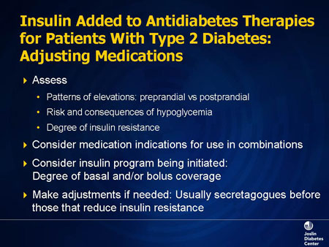
Slide 27. Insulin Added to Antidiabetes Therapies for Patients With Type 2 Diabetes: Adjusting Medications
The next step would be to continue with the oral medications and, at this stage, look at glucose patterns. The patient is on basal insulin, and you want to assess the degree of pre- and postprandial hyperglycemia. You want to know whether they are getting hypoglycemic in the middle of the night, whether they are very insulin resistant and require large doses of insulin, because that will affect your decision as to what you do with the oral medicines. If you decide to add a prandial insulin, the secretagogue would be reduced or removed from the treatment program. However, if this patient is very insulin resistant, then a thiazolidinedione or metformin would remain part of the therapy for its insulin-sensitizing effects. These adjustments are being made while you are gathering the data.

Designing an Insulin Treatment Program: Split-Mix Insulin Therapy
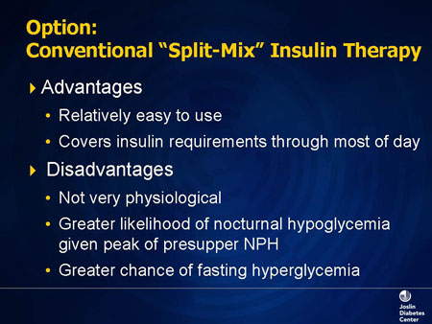
Slide 28. Option: Conventional "Split-Mix" Insulin Therapy
If the patient has developed significant postprandial hyperglycemia, the old approach was to go to a conventional split mix. In other words, we would use an intermediate-acting insulin with some fast-acting insulin, and give that twice a day. That was the way we treated diabetes for decades, but it is not a very physiologic approach. There is a greater likelihood that NPH will peak after midnight and give you nighttime lows, and patients do not always wake up with that. The newer sources of human insulin, even the intermediate-acting insulins, are not as long lasting. So a human NPH that is made from recombinant DNA technology does not last as long as the animal-source NPH had lasted, and you can get hyperglycemia with the waning NPH action.
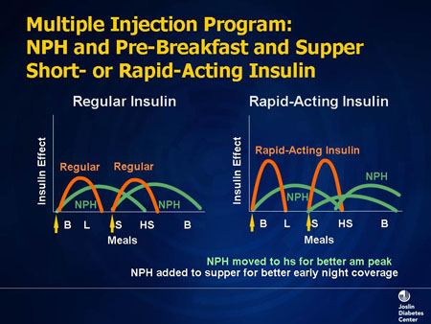
Slide 29. Multiple Injection Program: NPH and Pre-Breakfast and Supper Short- or Rapid-Acting Insulin
The old way of doing things was to use split mix, regular/NPH mixture, one third/two thirds, divided twice a day. In some cases, if the fasting glucose was high, the NPH was moved from suppertime to bedtime.
There was a 3-injection program that was used a lot: a mixture in the morning, fast-acting insulin before the evening meal, and NPH at bedtime. This was aided when the very-rapid-acting insulins came on the market, because they work more physiologically.

Designing an Insulin Treatment Program: Physiologic Insulin Replacement
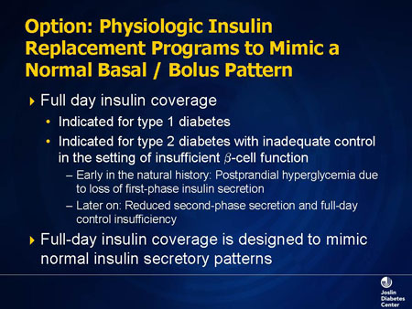
Slide 30. Option: Physiologic Insulin Replacement Programs to Mimic a Normal Basal/Bolus Pattern
The ideal situation is to adopt a physiologic program. If you started a basal insulin and the patient now has postprandial hyperglycemia, you need to do what the body normally does: provide full-day insulin coverage. For all type 1 diabetes patients, this is a given: they will require insulin before each meal. For a type 2 diabetes patient, you will identify where the hyperglycemia occurred postprandially, and target that particular meal after looking at the meal composition and other issues that may contribute to postmeal glucose highs.
In addition, type 2 diabetes gets worse in terms of hyperglycemia because of declining beta-cell function. Initially it is a loss of early insulin secretion, but eventually both early and late insulin secretion declines. Consequently, many of these patients gravitate towards a form of basal/bolus therapy.
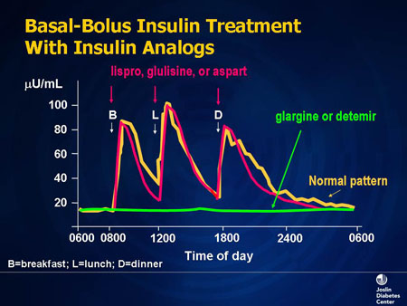
Slide 31. Basal-Bolus Insulin Treatment With Insulin Analogs
This is a current model of basal/bolus therapy. We use either detemir or glargine as our basal insulin, and then we give a premeal bolus, any one of the very rapid-acting insulin analogs (aspart, lispro, and glulisine) that fit normal physiology much better. The peak is rapid, and almost coincides with what happens with normal insulin secretion. It is a very good tool for meal control.
Remember, when we used regular insulin, patients had to take it 30 minutes, at least, before they ate? However, patients never waited 30 minutes; they took it just before they ate. With these insulins, you can take it and eat immediately. The danger is to take it and not eat; then you run the risk of becoming hypoglycemic, especially in type 1 patients.
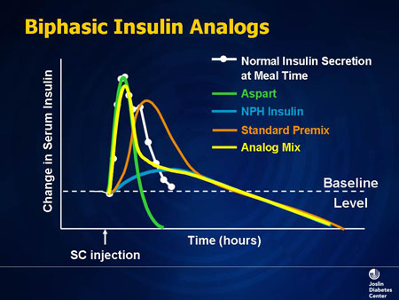
Slide 32. Biphasic Insulin Analogs
There are also analog mixes, which lend themselves very nicely to a basal/bolus approach for appropriate patients. This is where clinical judgment comes into play, and the total picture is assessed. There are some patients who require postprandial control, but not necessarily basal/bolus therapy and all of its components. Analog mixes could be a very nice middle step for some of those patients. It is not recommended for use in type 1 diabetes.
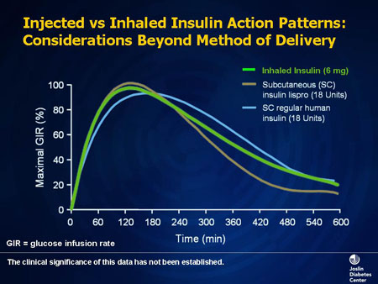
Slide 33. Injected vs Inhaled Insulin Action Patterns: Considerations Beyond Method of Delivery
Inhaled insulin has a profile much like lispro. We have no outcome studies that this insulin is superior. Most of the trials done to date are noninferiority trials, and it is equivalent in terms of the pharmacodynamics. It is not known if there will be improvement in glucose control.
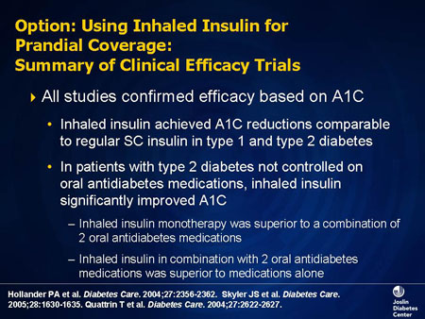
Slide 34. Option: Using Inhaled Insulin for Prandial Coverage: Summary of Clinical Efficacy Trials
All of the studies, in general, have confirmed using inhaled insulin for prandial coverage is effective; it depends on what the comparator is. If the comparator is regular insulin, inhaled insulin looks better. If the comparator is a fast-acting insulin analog, they are comparable. If the comparator to inhaled insulin monotherapy is two oral antidiabetes medications, insulin wins. If the comparison is a combination of oral medications vs inhaled insulin plus 2 oral medications, insulin plus orals win. The downside of some of these combinations is hypoglycemia. They do work; it is a matter of selecting the appropriate patient.
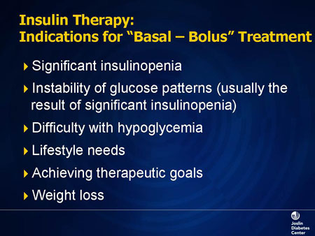
Slide 35. Insulin Therapy: Indications for "Basal-Bolus" Treatment
What are the indications for basal/bolus therapy? It is indicated in all type 1 patients and patients with type 2 diabetes, who as time goes on, become more insulin-deficient. There is a great deal of variability in their blood glucose levels; both postprandial and fasting levels go up. Remember, early in type 2 diabetes, there is postprandial hyperglycemia with the loss of early insulin secretion. Later in the disease there is fasting hyperglycemia, due to an overall decline in insulin production. These represent two different mechanisms, one at the liver for increased hepatic glucose output and the higher fasting glucose, and the other, decreased glucose utilization in muscle leading to postprandial hyperglycemia. And it takes much more insulin to put glucose into muscle than into fat. That is why postprandial glucose goes up early in type 2 diabetes.
Intensive insulin therapy, especially insulin pumps, is being used more often in patients with type 1 diabetes and even in those with hypoglycemic problems, especially hypoglycemic unawareness, because the delivery of a single type of insulin can ameliorate the problem to a great extent. We use this for patients who want intensive therapy. You would be surprised that young patients say, "I want the best control I can get. The shots and fingersticks do not worry me. Give me what you think is the best therapy today."
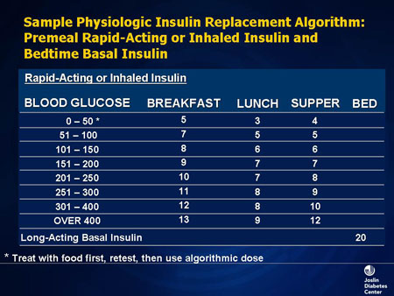
Slide 36. Sample Physiologic Insulin Replacement Algorithm: Premeal Rapid-Acting or Inhaled Insulin and Bedtime Basal Insulin
When giving a patient an intensive insulin therapy program, years ago we would give them an algorithm, which is a predetermined range of blood glucose, and then we would calculate a dose for each meal based on the amount of carbohydrates they were eating. Patients just looked at the number and took a certain amount of insulin.
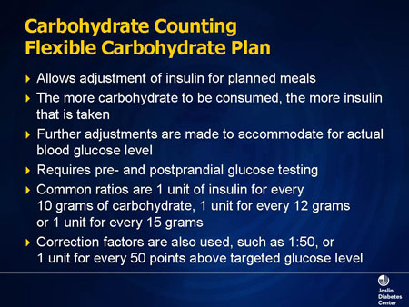
Slide 37. Carbohydrate Counting: Flexible Carbohydrate Plan
We have now moved away from these fixed algorithms. If we are going to do basal/bolus therapy correctly, I think we must include carbohydrate counting and education on this. The best way to adjust insulin is based on carbohydrate content; the more carbohydrates, the more rapidly they are absorbed, the more insulin that will be required. Patients are making these modifications every meal, and it requires pre- and postmeal testing. This is the premium policy that we are now selling; the patient has much more input and greater flexibility.
We will provide the tools to support that decision if patients are ready to make it. We will give them insulin-to-carbohydrate ratios. For instance, if you are having 2 slices of bread, and 1 slice of bread is 15 grams of carbohydrate requiring 1 unit, you will take 2 units of rapid acting insulin. More insulin-resistant patients will require a higher insulin dose per 15 grams of carbohydrate.
We also provide correction factors. Patients with diabetes do not always start a meal at their glucose goal of 5-6 mmol/L (100 or 110 mg/dL). If it happens to be 14 mmol/L (250 mg/dL) one day, for whatever reason, we give them a "correction factor" to help bring it down to 5.5 mmol/L (100 mg/dL). The standard that we use is 1 unit of insulin for every 3 mmol/L (50 mg/d)L above the targeted glucose level. For a very insulin-resistant patient, 1 unit may result in a 1 mmol/L (20-mg/dL) drop, and we adjust for that. Providing patients with these tools will give them the means to do this intensive therapy, and at the same time, achieve glycemic control on a daily basis, as well as lower A1C.

Summary
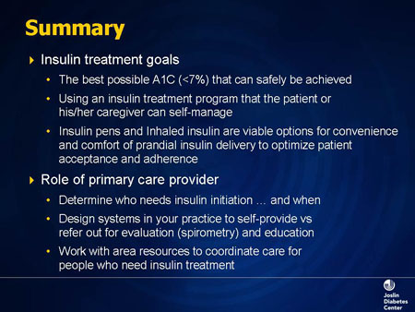
Slide 38. Summary
Essentially, we have a lot of tools in our toolbox. Just focusing on insulin, we have already made huge strides. We have effective insulin preparations, we have designer insulins, and now we have this cutting-edge new tool. We need to know where its place is going to be in our armamentarium, and as new players arrive, they also will find their place.
But I think the most important thing clinically is getting the best possible control, which is reducing A1C, the surrogate marker for glycemic control, to less than 7%, and we can do that very safely. The program that one chooses must be one in which the patient can participate fully, or if they cannot, their caregivers will be able to.
Insulin pens and inhaled insulin are viable options for prandial insulin delivery. Pens can also deliver long-acting basal insulins. In general, the acceptance has been very good with these devices.
What about the primary care provider? I think one of the key messages I would leave you with is: do not delay the initiation of insulin therapy. You can always start basal insulin. If there is an isolated peak of hyperglycemia, you can use an injection of rapid-acting insulin, or inhaled insulin is an option. But the delay of insulin therapy has been the problem to date.
Primary care providers can design insulin therapy programs, and if they are not comfortable doing that themselves, they can refer patients for evaluation. It can be a collaborative model, and if problems arise, someone can be there to help.
With inhaled insulin, the challenge will be how to work out some of the other issues, such as lung function testing; who is going to interpret it, and who is going to monitor it? We will work our way through these issues because every new tool goes through a period of uncertainty and then finds its own little niche. I am sure inhaled insulin, like the ones to follow, has a place in the therapeutic armamentarium.

